Power Production by Using the Hydroelectric Power Plants and Cost Effect on Electricity Market in Turkey
Irem Duzdarª*, Emre Uz^{b}, Gulgun Kayakutlu^{b} , M.Ozgur Kayalica^{b}
ªDuzce University, Duzce, Turkey; ^{b}Istanbul Technical University, Istanbul, Turkey
Industrial Engineering Department, Engineering Faculty, Duzce University, Duzce, Turkey; iremduzdar@gmail.com

Power Production by Using the Hydroelectric Power Plants and Cost Effect on Electricity Market in Turkey
Power production through hydroelectric power plants is one of the important methods to produce electricity because of the use of alternative resources while considering the climate issues in our current world. On the other hand, growing economies demand energy in the sectors, therefore, energy demand increases correlatively with sustainable economic growth. In this context, increasing power generation, reducing carbon emissions, and reducing energy generation costs by protecting energy reliability are the main objectives in an energy market. Since the climate issues, these aims require the utilization of the renewable energy source maximum at present. Accordingly, this study mainly aims at the economic analysis of the power generation from hydroelectricity in the electricity market for Turkey by comprehending the contribution of hydroelectric power plants. Since the 2050 roadmap of hydroelectricity might be beneficial to form the scenarios as realistic as possible by considering the hydroelectric capacity in Turkey, the long-range energy alternative planning (LEAP) model is used to analyze the cost-effectiveness by applying the scenarios. In this way, the acquired data regarding the energy demands and costs in the energy market for the different scenarios are used to make future predictions and aspects in Turkey.
Keywords: word; hydropower, cost effect, energy market, long-range energy alternative planning

Introduction
Natural resources have a high profit potential and a major impact on economic development since they can be found in nature without being produced. The existence of natural resources can provide economic development but the increase in population and the non-renewable nature of natural resources can cause natural resources to become an obstacle to economic growth. This non-negligible effect also creates a constraint (risk) on economic development. Besides, because of the rapid increase in human-induced CO2 emissions, it is seen that global climate change can create a significant constraint on the realization of sustainable economic growth (Çınar 2015). In addition, the abundance of natural resources can instill a false sense of security in people and cause governments to overlook the need for good and growth-friendly economic management, economies rich in natural resources, especially socially harmful rent-seeking behavior of producers (Gylfason, 2001). To protect the sustainability of the economy and prevent adverse situations due to the abovementioned effects, renewable resources should be used to produce energy and fulfill the demand coming from the producers and sectors. Because; as industrial activities that increase the economy increase, the consumption of energy obtained from natural resources and pollution also increase. This situation constitutes a situation contrary to the principle of sustainability. Therefore, it is necessary to reduce the use of resources that adversely affect the environment. In addition, renewable energy sources will positively affect economic development, as they will reduce foreign dependency on energy. Thus, it can be understood that the continuity problem experienced in renewable energy resources is tolerated by natural resources; and also, adverse environmental conditions created by natural resources are tolerated by renewable resources (Bekun et al. 2019).
On the other hand, energy and economy relevancy is investigated based on the tendencies and energy portfolios of the countries. The research shows that even though there is a bi-directional causality relationship between electricity consumption and the economy, the results may vary for different countries. Also, due to the reason of the distinction in the methodological approaches, the investigators may find different results for the same country (Yaşar and Sugözü 2019). These differences are very important since they shape the future energy policies of a country. However, because the direction of causality has important policy implications, economists often proceed by deriving energy policy implications based on Granger causality tests. If a unidirectional causality is found from energy to economy, a general result is; that limiting energy use will hinder economic growth. It is said that a result showing a continuous causality from economy to energy states that energy-saving measures can be carried out without putting economic development at risk. Bidirectional causality demonstrates the interdependence of energy and economy, so both variables must be treated as endogenous in a predictive model. Finally, when concluding there is a "neutrality hypothesis" in the analysis, the general explanation is that the economy will develop regardless of energy consumption patterns (Aydın 2010).
In a research made for Turkey, it is evaluated that there is bi-directional relevancy between energy and economy; however, the role of energy consumption is not too effective. This means the growth in GDP per capita and growth in energy consumption in Turkey move together, and Turkey has energy-saving opportunities without an adverse effect on economic growth (Lise and Van Montfort, 2007). Therefore, Turkey can make policies to encourage the use of renewable energy resources rather than natural sources for industries and households to reduce the high dependency on foreign energy. Moreover, in this way, Turkey has an opportunity to support economic growth by reducing energy imports, without endangering the energy supply security (Karaaslan and Çamkaya 2022). Evaluation of resource reserves, especially in the field of hydropower, is important in terms of providing a sense of balance between the use and security of the reserve (Turgeon 2016). In this context, this paper expects to contribute to another research that investigates economic development and economic relevancy by using innovative approaches. The low hydropower scenario regarding using hydropower plants in Turkey is investigated in this study to be able to analyze the effect of using Hydropower plants in the electricity market. For this reason, future aspects of Turkey’s energy policies might be considered specific to hydropower plants thanks to this paper, since it includes the current energy sources distribution and makes a scenario analysis (Di Leo et al. 2020).

Literature Review
Gross domestic product (GDP) values are one of the most important indicators since all economic activities can be summarized by using these values. Also, GDP data can be used to analyze the economy belonging to a country to compare the other countries and analyze their rates (Akkoyun & Gunay 2012). As per these values, policymakers and finance authorities check the economic progress and determine their policies to improve investment planning (Soybilen et al. 2023). Turkey is one of the largest economies in the world with 795 billion US$ in 2021 according to the IMF World Economic Outlook Database, despite the decreased economic growth owing to the recession in 2019 and also the effects of the pandemic issues all over the world in 2020 (Berganza et al. 2021). The main reason for this economic stagnation is that Turkey’s export industries related to the manufacturing sectors such as textile, machinery, chemical and metal products, etc. adversely affected, and the vulnerability of the sectors is still ongoing related to the COVID-19 economic factors (World Bank 2020).
However, previous publications and predictions show that Turkey can increase its growth rate and GDP since it has young and qualified laborers, tourism incomes, automobile production, assembly sector, and be in the position of a center for the food industry. It also has plenty of opportunities to increase its installed energy capacity by using its renewable resources. If Turkey fulfills its potential, it might improve the export sectors, and develop the energy supply infrastructure to provide energy to the crucial manufacturing sectors, and it might take a place on the list that can be considered successful compared to the past years. (Dincer et al. 2015). All these requirements are required to an adaptation to the Turkish energy market by using renewable energy resources. To analyse the costs in the electricity market, a study was published (Acar et al. 2019), which shows to effect the hydropower plants had on electricity prices between 2012 and 2017. The hydropower generation led to imbalanced costs in Turkey’s electricity market and these costs reflected consumers via a feed-in-tariff system (Shen et al. 2022). Turkey’s electricity market is carried out on the day ahead and bilateral contracts. Demand and energy generation are continuously changing. Turkey implements feed-in tariff mechanisms to encourage renewable energy investments. Research exhibits that hydropower capacity has an increasing tendency as wind turbines, and forecasting errors are similar as well. The study reveals imbalance costs are reflected in the consumer. To overcome this situation, two principles are queried, the locational marginal pricing method and the differentiation of the feed-in tariffs according to the location of the plant (Selcuk et al. 2019). One of the main issues with HPPs is the uncertainty of using renewable resources when discussing the effects of HPPs on the electricity market (Tutak and Brondy 2022). The economic impacts of renewable energy developments are classified as growth, feedback, conservation, and neutrality. The development of renewable energy needs investment potential and technical support. Due to this situation, renewable energy plans should be evaluated by taking into consideration economic policies (Aslan et al., 2022; Gunn et al. 1992).
On the other hand, since the decarbonisation aims, electricity market integration of hydropower plants is studied for two outputs; hydropower production characterization and integrity to the grid to meet the peak loads. In addition, it is expected that the two outputs can provide low-cost renewable energy between areas by providing a greater economic value to power production. The capacity expansion model results show that decarbonization is a burden on total costs. For this reason, it is proposed to expand the interconnection grid to obtain the largest cost savings. The benefits of integrating power plants are described as it is an option to provide flexibility and balance the wind energy (Rodríguez-Sarasty et al. 2021). Growing economies need energy to sustain their growth by meeting the energy demand. Energy security can be identified as one of the most important criteria to keep the market in balance. Energy security also determines supply security between producers and consumers, and energy prices increase for high foreign dependency correlatively in Turkey. The market costs and energy security are more delicate due to the adverse foreign effects. Therefore, domestic energy capacities including hydropower from renewable energy sources should be increased exactly. The energy policies support diversifying the power-producing, and energy pricing mechanisms should be carried out to retain competitiveness in the sectors (Biresselioglu et al. 2017). Turkey plans to increase the installed hydropower capacity since it has a growing economy with a young population. In this way, the market can be utilized from renewable sources. Hydropower in Turkey is one of the lead power production methods historically, and it will be the same for Turkey in 2023 according to official future predictions. New turbines provide higher efficiency for energy generation than conventional methods such as natural gas and coal turbines. Many benefits can be considered for hydropower; energy price stability and reliability for the electricity grid. Turkey has considerable hydropower potential in the Black Sea Region especially (Melikoglu 2013).
Long-term-based energy plans are scrutinized by considering the role of hydropower in meeting the demand for Turkey. Hydropower is a distributed method in the interconnection grid to generate electricity, for this reason, it can provide flexibility and independence. Turkey’s hydropower potential can reach up to 33%-46% of Turkey’s total electricity demand (Yuksek et al. 2016). Hydropower is three times more efficient than other renewable generation methods. The rate of increase of hydropower plant installation is increasing thanks to privatization in energy policy laws (Bilgili et al. 2018). A comparative approach is adopted about renewable energy sources, and hydropower is the most common and the largest renewable energy source that is used all over the world. Also, Turkey is mentioned among the top 10 countries in terms the power potential (Bilgili et al. 2015).

Overview of Turkey’s Electricity Market
In the middle of the 2000s, Turkey was the 25th country in the world in regards to sharing of the CO₂ emissions. It has a 1% proportion of CO₂ Emissions all over the world because of the high dependency on fossil fuels. Turkey has a considerable amount of coal potential to be able to use in thermal power plants. Besides this situation, petroleum and natural gas were the other main energy sources to generate electricity in the country (Transparency 2020). The Paris Agreement was adopted in 2015 and it is signed by 194 countries and the European Union as of February 2021. This agreement aims to limit this century's global temperature rise to 1.5 degrees Celsius to respond to the global threat of climate change. As stated in a report, Turkey’s GHG emissions have increased by 134% from 1990 to 2017, and the proposed target for 2030 is not in accordance with the 1,5°C pathway as per the Paris Agreement. The largest contributors to CO2 emissions in Turkey, at 33% electricity sector, 24%, and 22% industry and transportation sectors respectively. When the distribution of the energy sources is considered, fossil fuels (oil, coal, and gas) still make up 82% of Turkey’s energy spectrum, this rate is the same as the G20 countries’ average (Şahin 2020).
Turkey plans to increase the installed renewable power capacity every year. The installed capacity of total renewable energy including hydro energy has increased from 15,529 MW in 2009 to 42,339 MW and from 14,553 MW in 2009 to 28,293 MW in 2018, respectively. When the last five-year period (from 2014 to 2018) was evaluated, the average annual growth rate was obtained as 10.95% and 4.59% for Turkey’s total renewable and hydro energy installed capacity. EPDK is the lead regulative institution in the electricity market in Turkey. Turkey supported the private sector to get high participation in electricity generation in 2001. The institution surveys the electricity market through the Electricity Market Laws including demand, demand forecast, efficiency, balancing and settlement, distribution and retail sales, etc. According to EPDK’s report, Turkey’s total licensed and unlicensed installed capacity occurred as 88,498 MW at the end of 2018 which means that the share of total renewable energy and hydro energy is equal to 48% and 32%, respectively (Bilgili et al. 2022).
On the generation side, the private sector and government-owned side are working together because of Turkey’s mixed economy traditions in Turkey. EUAS is the lead company to regulate the energy market for government-owned companies. It is expected that EUAS will be regulative for the generation side to compensate the prices by taking into consideration losses and street lighting (IEA 2021).
TEIAS received a license under supervision from EPDK to transmit energy in Turkey. TEIAS was restructured accordingly since it is still a monopoly in the energy market to use the private sector efficiently. The institution is a state-owned company that is solely authorized for both the operation of the interconnected grid and the transmission of electrical energy. The energy imports and exports with the contiguous countries are carried out by using the interconnected network (TEIAS 2022).
The total power generation capacity of Turkey increased by 103.3 GW at the end of October 2022. In the first ten months installed power-generating plants raised to approximately 3,456 megawatts (MW). The reason for this rise is the power plants that produce electricity by using renewable sources. The main part of this capacity, 1,305 MW, is from hydroelectric power plants (HPP), 700 MW of it from wind power plants (WPP) and 76 MW is from the solar power plants (SPP). While the net 269 MV power generation capacity using natural gas and various sources decreased. There is an increase to 1,380 MV total power generating capacity at the imported coal power plants (TSKB 2022).
The report also provides information regarding the distribution of power plant numbers and installed power capacities according to sources including both renewable resources and non-renewable resources. The installed power capacity is shown historically by a graphic (Fig.1) from 1970 up to now (TEIAS 2022).

Figure 1. Turkey’s Installed Power Capacity by Years (TEIAS 2022)

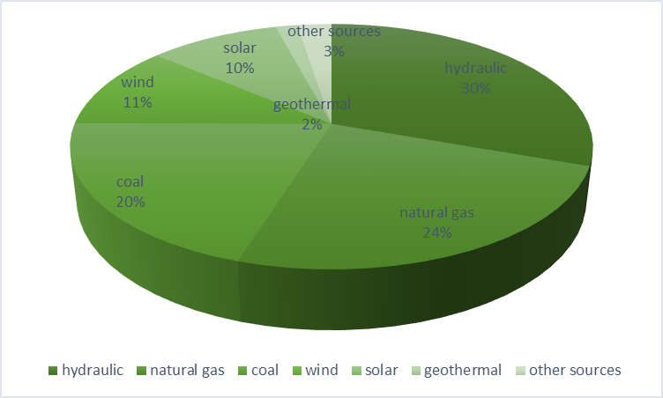

Figure 2. Installed Power by Resources (RTMEN 2023)

By the end of May 2023, the installed capacity of Türkiye has reached 104,672 MW. As of the end of May 2023, the distribution of installed capacity by resources is as follows: 30.2% hydraulic, 24.2% natural gas, 20.8% coal, 11% wind, 9.6% solar, 1.6% geothermal and 2.5% other sources. Additionally, as of the end of May 2023, number of electricity generation plants in our country has reached 12,057 (including unlicensed plants). The distribution of power plants by resources is as follows: 751 hydraulic, 67 coal, 361 wind, 63 geothermal, 346 natural gas, 9,979 solar, and 490 other power plants (RTMEN 2023).
The electricity market of Turkey was divided into 21 electricity distribution areas for retailing electricity. Each of them is constructed under TEDAS and it is responsible for the distribution of electricity. The privatization was done in the first half of the 2010s in the market. In the current circumstance, free consumers can select the providers from the market, but the infrastructure belongs to local distribution companies (Erdogan 2022).
In the Turkish electricity market, the reference price between hours is determined by the merit order method. With this method, it is aimed that the system will produce electricity at the most affordable cost. The basis of method is based on minimizing the costs of thermal power plants with high production costs and maximizing the use of renewable energy sources whose marginal cost is accepted as zero. Simply put, power generation plants are ranked from the cheapest to the most expensive according to their production cost, and the plants that will meet the demand from the cheapest to the most expensive according to the energy demand at the relevant hour are put into operation in order. The last power plant that meets the demand, that is, the most expensive power plant activated at the relevant hour in the system, determines the reference price of the system for the relevant hour. Each step in the below graphics belongs to a power generation type. The equilibrium point shows that the demand is met at this point through the power plants that are shown (Fig. 3) on the left side of the QE and underneath PE (Hirth 2022).
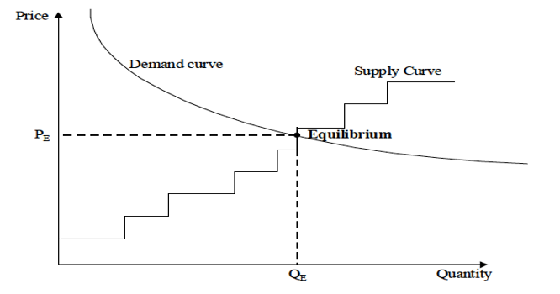

Figure 3. Sample of Merit Order Curve (Hirth 2022)

As stated in the previous section, the Feed-in-tariff system, which Turkey has operated based on Law No. 5346 to encourage renewable energy investments, is an important factor to be considered in the electricity market. Within the framework of Law No. 5346 on the Use of Renewable Energy Resources for Electric Power Generation (YEK Law), hydroelectric power plants with wind, solar, geothermal, biomass, waves, currents, tides, and canals or rivers or reservoir areas less than fifteen square kilometers can benefit from Feed-in-Tariff for 10 years (Table 1). Different price tariffs are applied for different power plants, depending on the situation of commissioning after or before June 2021. In addition to licensed power plants, unlicensed power plants (which do not exceed the installed power capacity of 1MW) can also benefit from feed-in tariff (IEA 2021).
Power Plant Type  (Commissioned Before June 2021) | Feed-in-Tariff  (dollar-cent/kWh) |  | Local Component Incentive  (dollar-cent/kWh)
Hydropower | 7,3 |  | 1,0-2,3
Wind | 7,3 |  | 0,6-3,7
Geothermal | 10,5 |  | 0,7-2,7
Biomass | 13,3 |  | 0,4-5,6
Solar | 13,3 |  | 0,5-6,7
Power Plant Type  (Commissioned After June 2021) | Price  (lira-kuruş/kWh) | Local Content  (lira-kuruş/kWh) | New Upper Limit  (dolar-cent/kWh)
Hydropower | 40 | 8 | 6,4
Wind | 32 | 8 | 5,1
Geothermal | 54 | 8 | 8,6
Biomass (Average Value) | 45 | 8 | 7,2
Solar | 32 | 8 | 5,1
Table 1. Feed-in-Tariff Prices in Turkey for Renewable Resources (IEA 2021)

If the table is evaluated, it comes out that the guarantee fee support has decreased with the law changes made in June 2021. This circumstance arises because Turkey has started to implement the green electricity tariff (YEK-G). After the power plants that generate electricity from renewable sources become widespread and these power plants have a certain share in electricity generation, Feed-in-Tariff, which usually leads to a big financial burden, is exited and alternative approaches are started (IEA 2021).
The green electricity tariff is one of these alternative mechanisms. According to this tariff, producers can increase the use of renewable energy sources in electricity production. Supply companies can verify that they have renewable energy in their portfolio. Consumers can contribute to reducing the effects of climate change and protecting the environment, by obtaining information about the source of the energy they purchase. The YEK-G market started to operate in June 2021 and is organized and operated by EXIST (TSKB 2021; EXIST 2023).
In a report released in January 2022 (TSKB July 2022), power plants generating electricity from renewable sources constituted 53.9% of the power plants that were operational in January 2022. Thus, the share of renewable resources continued to increase, staying above the 53% level. The share of hydroelectric power plants in the total generated electricity in Turkey in January 2022 is 16.5% in Turkey. Also, when the daily market-clearing price analysis is made for January, the average of peak hours is 1,265.81 TL/MWh, and the average of non-peak hours is 1,090.16 TL/MWh.
At the end of May 2023, the established power-generating capacity of Turkey reached 104,672 MW. The distribution according to the sources of the established power plants at the end of May 2023 is 30.2% hydraulic, 24.2% natural gas, 20.8% coal, 11% wind, 9.6% solar, 1.6% geothermal, and 2.5%. In addition, the number of power generation power plants (including unlicensed power plants) that were completed at the end of May 2023 reached 12,057. The distribution of them in numbers according to used resources are 9,979 solar, 751 hydraulic, 346 natural gas, 67 coal, 361 wind, 63 geothermal, and 490 other power plants (TSKB July 2022).
Consequently, both the support of renewable energy investments and the commissioning of power plants according to unit electricity production prices are determined simultaneously from a foresighted point of view. At this point, considering factors such as time intervals and seasons, it is endeavoured to be met with minimum emission and cost without jeopardizing the energy supply of the baseload.

Turkey’s Hydropower Potential
The hydropower capacity of a country depends on climate conditions. Turkey is situated between a latitude of 36°N–42°N and a longitude of 26°E–45°E in the northern hemisphere. Therefore, it can be asserted that Turkey is situated between the subtropical zone and the temperate zone. The southern side of Turkey is closer to the equator than the northern side inherently. It is observed the Mediterranean climate conditions where summers are hot and dry and the winters are mild and rainy on the southern side. On the other hand, the Black Sea Climate where summers are cool and winters are warm in the coastal area, snowy and cold in the higher parts of the northern side of the country. Accordingly, the northern side has more capability to receive rain, especially the northeastern side in the black sea region. The distribution of precipitation in Turkey is located by the sea, landforms, elevation, and direction of geographical factors to affect the stretches of the mountains. Considering all these factors, the Black Sea region receives the most precipitation throughout the year regularly. Even if Turkey has an average of 643 mm of precipitation annually according to DSI data as indicated in (Gökdemir et al. 2022; Çiçek and Ataol 2009), this value is 574 mm while the recent years are considered as per data released by the ministry of environment and urbanization on their website. According to research, 501 billion m³ of annual precipitation is obtained when this precipitation amount is calculated.
The average exploitable water potential of the country is 12 billion m³ per year. In addition, 1/3 of the water potential barely was in 2006 in Turkey. It is thought that the entire water potential will be used in 2030 (Yuksel 2021). In a study made in 2012, Turkey has 216 TG-h/yr Technical Hydropower Potential and 140 TW-h/yr Economic Hydropower Potential (Figure 5).

Figure 5. Breakdown of Turkey’s Hydropower Potential in TWh/year (Balat 2015)

Table 2 shows that although Turkey has a larger economically feasible hydroelectric power potential compared to leading European countries such as Norway and Sweden, it lags far behind in bringing this potential to the economy (Capik et al. 2012).
Country | Technical Hydropower  Potential  (TW h/yr) | Economically Feasible  Hydropower  Potential in 2005 | Actual  Generation  In 2005  (TW h/yr) |  | Development Economical Potential (%)
Turkey | 216 | 130 | 47,87 | 36
Norway | 200 | 187 | 136,6 | 73
Sweden | 100 | 85 | 72,9 | 86
France | 100 | 70 | 56,5 | 81
Italy | 105 | 65 | 42,9 | 66
Austria | 75 | 56 | 38,6 | 69
Switzerland | 43 | 41 | 33,1 | 81
Spain | 66 | 32 | 23 | 72
Germany | 25 | 20 | 26,7 | 134
United Kingdom | 3 | 1 | 7,9 | 789

Table 2. Comparison of Hydropower Potential In Some European Countries (Capik et al. 2012)

In this sense, the national development plan for hydropower should be prepared for the effective use of all hydropower potential as stated in the article (Yuksel et al. 2016). Increasing the share of hydroelectric energy in total energy production and consumption is the easiest way for Turkey to increase the effective use of renewable energy resources. To achieve this, laws that can create incentives for entrepreneurs and investors should be established. To be able to do this, it is necessary to increase constantly the applicability of the laws numbered 5348 and 5784 and to check rigorously whether they are beneficial to the entrepreneurs in the market. This situation supports one of Turkey's foremost objectives, which is to join the European Union (Erdogdu 2011).

Future Predictions for Turkey’s Renewable Energy Using Proportion
The report “Turkey’s Decarbonization Roadmap: Net Zero in 2050” investigates Turkey’s CO2 emissions under different scenarios including the electricity sector. In these scenarios, it is taken into account that the nuclear power plant at the Akkuyu/Mersin is commissioned. (EPRA, 2022). The total installed power potential of Turkey regarding renewable resources is included in the research (Cebeci 2017) with details. It is expected in this study that the solar power capacity is 56 GW, hydropower capacity is 36 GW, and, wind power capacity is 48 GW in Turkey. It corresponds to the energy production of 140 Twh-year for hydropower, 128 Twh-year for wind, and 380 Twh-year for solar. Based on these studies, the values indicated below are considered to analyze the cost effects. For the 2022 year values, the TEIAS report examined the “Overview of Turkey’s electricity market” section in this study. Table 3 shows that 2030 total installed power capacity shows parallelism with another research that evaluates the scenarios for electricity generation if the low demand or local resource scenarios in the research are considered (Shura 2020)

 | Hard  Coal | Imported  Coal | Lignite | Natural Gas | Other | Nuclear | HPP  (Dam) | HPP  (RoR) | Solar | Wind | Geothermal | Biomass | Total
2022 | 0,8 | 8,9 | 10,1 | 25,3 | 1,0 | 0,0 | 23,2 | 8,2 | 7,9 | 10,6 | 1,6 | 1,6 | 99,2
2026 | 0,8 | 11,7 | 12,8 | 26,6 | 2,8 | 0,0 | 24,5 | 8,2 | 13,6 | 11,2 | 2,0 | 2,2 | 116,4
2030 | 0,9 | 11,7 | 14,9 | 27,1 | 3,6 | 4,8 | 25,5 | 8,3 | 18,9 | 14,1 | 2,4 | 3,0 | 135,2
2035 | 1,0 | 11,5 | 17,1 | 29,8 | 4,1 | 4,8 | 26,0 | 8,3 | 28,1 | 18,2 | 3,0 | 4,5 | 156,4
2040 | 1,0 | 11,5 | 21,3 | 32,2 | 4,7 | 4,8 | 26,5 | 8,4 | 37,3 | 28,9 | 3,0 | 5,0 | 184,6
2045 | 1,0 | 12,9 | 21,2 | 37,3 | 4,9 | 4,8 | 27,0 | 8,5 | 46,7 | 42,2 | 2,8 | 4,9 | 214,2
2050 | 1,0 | 16,7 | 21,2 | 43,2 | 5,0 | 4,8 | 27,5 | 8,5 | 56,0 | 48,0 | 2,8 | 4,8 | 239,5

Table 3. Estimated Development of Installed Power by the Sources In Turkey (GW) (Shura 2020)

Methodology Review
Various research was released to analyze the future predictions belonging to a region. One study examining Colombia’s energy dynamics was adopted within two scenarios. Once is characterized by lower economic growth than the other one. The main objective is to identify the impacts of technical changes to energy supply and greenhouse gas emissions. LEAP software that can enable an analysis of energy planning policies is used to evaluate the energy demand and greenhouse gas emissions, and power generation cost analysis as well. Sectors are investigated for two scenarios separately. In the results chapter of the study, using the energy sources proportions are listed according to scenarios (Nieves et al. 2019). Another similar approach examines the environmental and socio-economic effects of using LEAP for Zhangjiakou City between 2016 and 2050 years. The objectives of the paper are to analyze future trends, energy carbon dynamics, and implications for future policies. LEAP-Zhang model in the study has six modules including end-use demand and demand prediction. Calculating cost is another output that is obtained by taking into consideration utilization. A comparison of the conventional and renewable resource cost effects is made under two scenarios. BAU is the reference scenario for the INT scenario. Under the INT scenario, it is predicted that the electricity generation cost would decrease to 0,073 USD/kWh. These generation costs are considered under the socio-economical effect title in the flow chart of the model (Yang et al. 2021). A study made for Nigeria aims to research energy policy queries by using LEAP. The queries are explained as meeting energy demand at minimum cost without increasing greenhouse gas emissions, and sustainable energy policy for low carbon developments. Cost-benefit analyses are also included in the study for the sectors. Besides the sectors, it is emphasized that household energy use needs to be reconsidered immediately to reduce energy consumption and achieve high energy efficiency in the country. All analyses are constructed based on four scenarios in the study. According to the LCA scenario, 40% renewable energy resource use is possible in the country in 2040. In this situation, electricity power generation on hydro will increase by %9, biomass will increase by 5%, and PV systems will increase by 2% (Emodi et al. 2017).
In the study of He et al. (2023), the consumption of the energy nationwide and LEAP-based energy mix for several various scenarios is simulated. The proposed optimization technique for China in this study is the wind power with the photovoltaic implementations together by combining the LEAP model the readiness of the technological level and involving the cost reduction model. At the end of this research, the total cost of the project decreased by 3.23% maximum (Xianya et al. 2023). In another study, the LEAP model is employed to define the dependence between the implemented wind power utility and the technological maturity. At the same time, it simulates the energy consumption and the nationwide carbon emission. It is stated that the suitable and fast transition to wind power and energy sources will be effective in technological improvement and reducing costs. Meanwhile, the lower total costs will be seen, because the costs of technological maturity of the future can be covered in the initial investment (He et al., 2004). In the paper of Gebremeskel et al. (2023), the Ethiopian electricity system is analyzed in detail, and employing the LEAP a model is constructed. Result of the improvements in the scenario, the established capacity is decreased by 9 GW. This means 11% less cost and the saved total cost is $4 billion (Gebremeskel et al. 2023).
LEAP is used for generation expansion plans based on the scenarios to get better energy and economic policies. LEAP framework allows querying how much impact would the cost of a future electricity supply scenario. Optimum scenarios might be estimated for a region, and the growth of the economy and energy costs can be investigated subsequently for the scenarios (Shahid et al. 2021). Similar methods differentiated from LEAP are used to energy future policies. For instance, WEAP is used to discover the water-energy nexus to forecast the water supply. Water and energy relevancy provides an opportunity to connect the sectors to each other. The base scenario is investigated for LEAP and WEAP separately to get realistic results (Liu et al. 2021). The maximum total levelized costs are used in LEAP to estimate the prices for different power generation methods. Losses and constraints are to be determinative of the accuracy of the results (McPherson and Karney 2014). The LEAP structure is shown in Fig. 5.

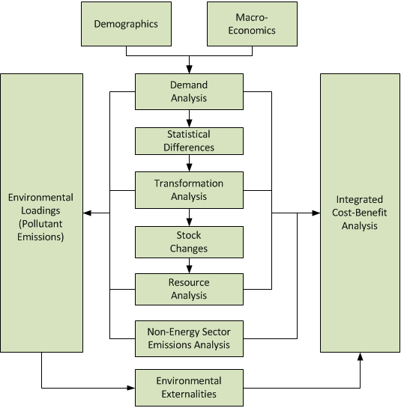
Figure 5. Leap Structure

LEAP Results and Analysis
Leap platform has energy demand, energy transmission, and resources. These main topics are structured according to the rate of use of Turkey's hydroelectric potential in 2050 and cost-benefit analysis for energy demand has been made. The first of the scenarios is the baseline scenario in which Turkey has used alternative energy sources, including hydroelectric energy, at full capacity, in the 2050 roadmap specified in the table above. The other "low hydro capacity" scenario is based on the assumption that Turkey will produce energy in 2050 with installed hydropower of 15 MW, which can be considered half of its current capacity. To create a controlled experimental group; in the low-capacity hydroelectric scenario, the remaining capacity that needs to be completed has been allocated to coal and natural gas conversion power plants. During this sharing, due to the presence of domestic resources, a ratio of 2/3 to coal and 1/3 to natural gas is envisaged. As a result, in the baseline and low hydrocapacity scenarios, Turkey has an installed power of around 238 MW and in the baseline scenario, approximately 36 MW of this belongs to the hydroelectric power plant, while in the low capacity hydroelectricity, this value is 15 MW. In addition, each power plant type is divided into 2 groups named existing and new, and the values of exogenous and endogenous capacities in the future projection are processed in this context. The estimated installed power capacities for the 2050 year are included in Table 4 as per the created scenarios.
 | Baseline  Scenario  in 2050 (MW) | Low-Hydropower Scenario  in 2050 (MW)
Hydropower | 35.987,50 | 15.000,00
Wind | 47.682,50 | 47.682,50
Solar | 55.981,10 | 55.981,10
Biomass | 5.058,00 | 5.058,00
Natural Gas | 43.205,30 | 50.171,14
Geothermal | 3.076,20 | 3.076,20
Charcoal | 38.441,30 | 52.372,97
Heat | 4.090,30 | 4.090,30
Nuclear | 4.800,00 | 4.800,00
Total | 238.322,20 | 238.232,21
Table 4. Total Installed Power Capacities

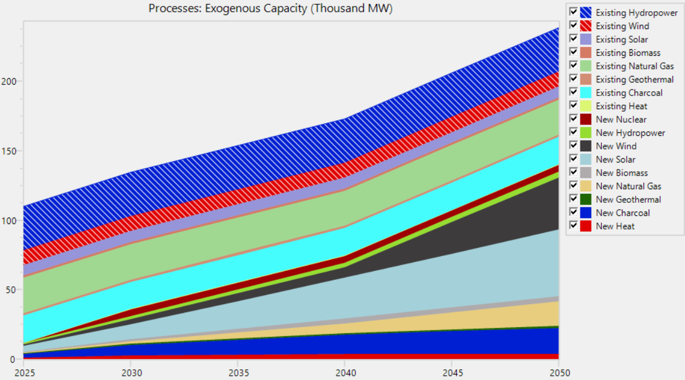

Figure 6. Exogenous Capacities (Thousand MW)

Energy Demand
Turkey's energy demand has been analyzed in 4 sections including household, industry, transport, and commercial. It is assumed that the number of households was approximately 21 million in 2022 and it will increase linearly by 0.46% annually. While 93% of the total population lived in urban areas in 2022, it is estimated that this rate will be 95% in 2050 according to TUIK (Turkish Statistical Institute) data and statistical projections. The energy demand of the households has been examined for lighting, refrigeration, cooking, and others. Although the distribution of energy consumption in the city and rural areas is parallel, the use of energy is a bit higher in the urban areas in (TUIK 2023).
Regarding the transportation sector, the railway is taken into consideration and TCDD (Turkish State Railways) data is used. Accordingly, it has been observed that approximately 90% of the passengers travel by electric trains and the passenger transportation sector constitutes the majority of the energy demand in the analysis (TCDD 2019). However, the proportion of the transportation sector in Turkey's total energy demand is 25% (Ministry of Environment and Urbanisation, 2023). According to statistics, it is seen that the share of railway transportation in the whole sector in terms of passenger-km is 1.2%. It is obtained that the share of the railway transportation sector in the total energy demand is 0.3% accordingly. Therefore, TCDD passenger number data has been degraded in the model.
For the industry, the iron-steel sector is discussed. Energy sources are determined as coal, electricity, and natural gas. In addition, other sectors were examined under the general heading, and electricity and fuel oil consumption were proportioned in Fig. 7. Total production capacity of 40 Mtoe is also evaluated for this section (KPMG 2015).
The heating branch has been examined for the general commercial sectors and the use of electricity, natural gas, and fuel oil has been evaluated the total closed commercial area is expected as 600 million square meters. Accordingly, total installed power capacity and energy demand will increase year after year in Table 5.

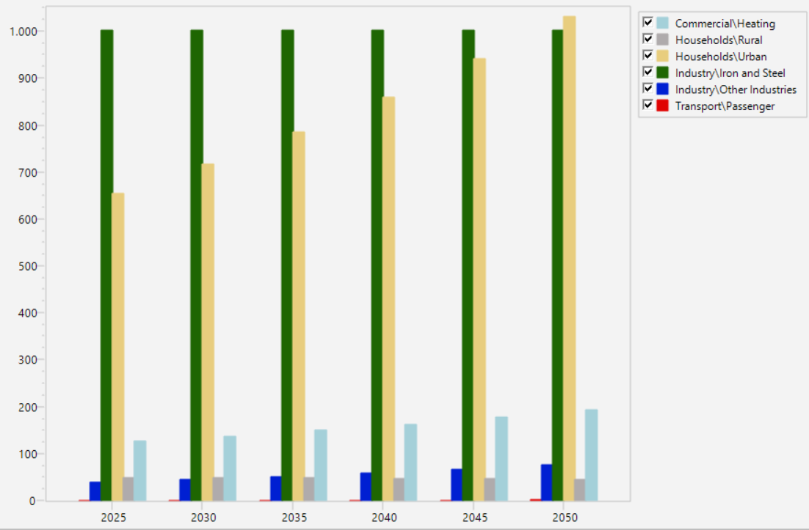
Figure 7. Final Energy Demand (Million GJ)
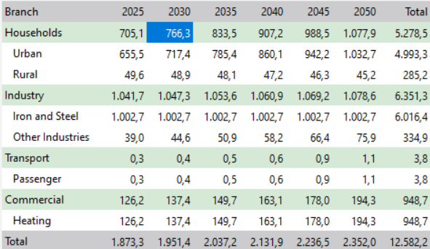
Table 5. Chart Table for Final Energy Demand (Million GJ)

Transformation
In this section, the transformation of energy from one form to another is examined, and since the energy market analyses are made as output fuels, only electricity is evaluated. Therefore, it can be stated that energy production and energy transmission-distribution processes are studied.
Since the effects on the electricity market in energy production are examined, only electricity is considered as output fuel. In the power generation methods section, the sources that produce energy are listed. The installed power and future scenario capacities of the existing power plants in electricity generation in 2022 are given under the titles of endogenous and exogenous.
Other criteria evaluated in this part are the efficiency of the power plants, merit order dispatch, maximum availability, and historical production. It has been considered that there will be some efficiency increase in alternative energy sources in the future for power plant efficiencies. Alternative energy sources, including hydroelectricity, have been prioritized for merit order in the first category by the feed-in tariff. Exceptionally nuclear power plant since it has priority to purchasing guarantee is considered in the first category. When these resources cannot be used, the next resources in Category 2 will be able to complete the base load such as charcoal and natural gas.
The total electricity losses ratio including distribution and transmission is assumed 14% as an average value that is gathered information from the different authorities. In addition, natural gas losses and leakages are also taken into consideration, and it is assumed that these values for electricity and natural gas will be 10% and 4% in 2050 respectively. The majority of losses in the electricity system occur in distribution networks and this situation has both technical and non-technical aspects. There are studies on various data analyses and projections to reduce losses. Power generation will increase according to created scenarios year after year to correspond to the energy demand in Turkey (Fig. 8).

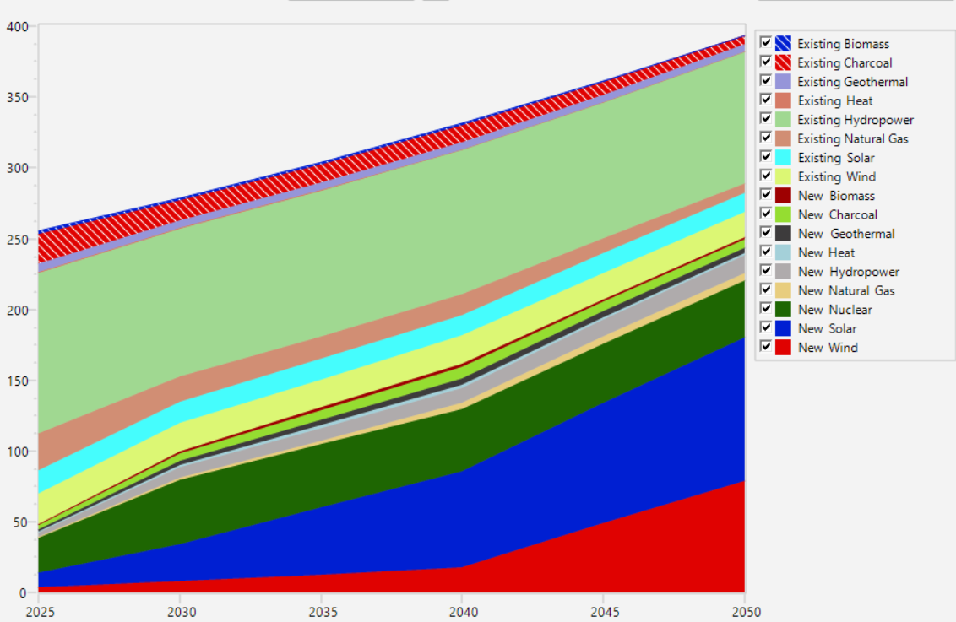
Figure 8. Total Power Generation (GW)

Cost-Benefit Analysis
The cost-benefit analysis is used to analyze all the steps mentioned in the previous sections according to the economic parameters. Energy consumptions for energy demand, defined by the scopes created for household, industry, transportation, and commercial groups, are considered within the scope of final energy intensity and consumption prices within the scope of demand cost. The changes in these values according to the future trends for the scenarios are arranged according to the expectations that there will be some improvements in energy efficiency.
In energy production processes, capital costs, fixed O&M costs, variable O&M costs, indigenous costs, and import costs data for resources are evaluated according to (Kaya and Koç 2015); IEA 2021; IRENA 2012).
The Levelized cost of electricity (LCOE) is a term used for the valuation of investment and O&M costs to be used in electricity generation from different sources.

∑P_{MWh} * MWh * (1+r)^{-t} = ∑[(Capital_{t} + O&M_{t} + Fuel_{t} + Carbon_{t} + D_{t}) * (1+r)^{-t}] (1)
LCOE = P_{MWh} = ∑[(Capital_{t} + O&M_{t} + Fuel_{t} + Carbon_{t} + D_{t}) * (1+r)^{-t}] / ∑ MWh (1+r)^{-t} (2)
where;
P_{MWh} = The constant lifetime remuneration to the supplier for electricity;
MWh = The amount of electricity produced in MWh, assumed constant;
(1+r)^{-t} = The discount factor for year t (reflecting payments to capital);
Capital_{t} = Total capital construction costs in year t;
O&M_{t} = Operation and maintenance costs in year t;
Fuel_{t} = Fuel costs in year t;
Carbon_{t} = Carbon costs in year t;
D_{t} = Decommissioning and waste management costs in year t.
Finally, the cost values are obtained and used for the analysis including in Table 6.

Power Generation  Method | First Investment Cost  ($/kW) | Fixed O&M Cost  ($/kW-year) | Variable O&M Cost  ($/kW-year) | Energy Production Cost  (cent/kWh)
Nuclear | 5530 | 93,28 | - | 9,2 - 13,2
Geothermal | 4363 | 100 | 2,14 | 8,9 - 14,2
Biomass | 4114 | 105,63 | 5,26 | 8,7 - 11,6
Solar | 3873 | 24,69 | - | 18,0 - 26,5
Charcoal | 3246 | 37,8 | 4,47 | 6,6 - 15,1
Hydropower | 2936 | 14,13 | - | 2,7 - 3,5
Wind | 2213 | 39,55 | - | 3,7 - 16,2
Natural Gas | 917 | 13,17 | 3,6 | 6,1 - 8,7

Table 6. Cost Values
All data is implemented on the LEAP platform as mentioned in the sections and the cost-benefit analysis is obtained in Figure 9.
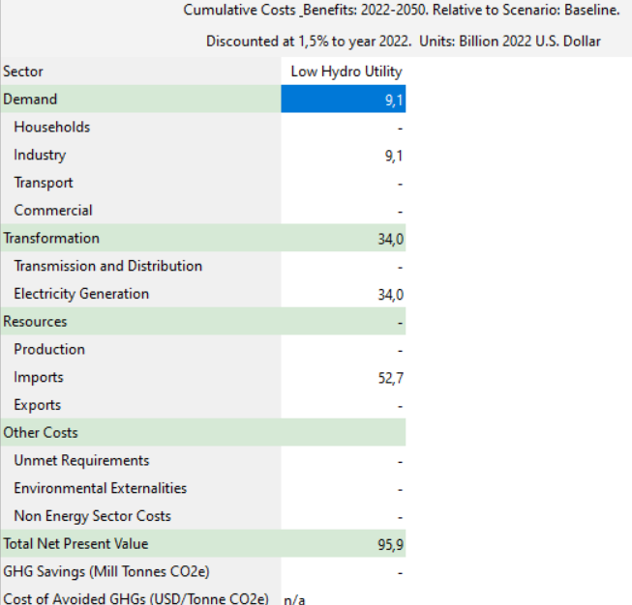
Figure 9. Cost Benefit Analysis Summary
As per these data, the net present value shows how much more cost mitigation has than the baseline scenario. Accordingly, if the capacity and electricity production loss in hydroelectric power plants is fulfilled with coal and natural gas, this will have an increasing effect on electricity prices.

Conclusions and Suggestions
According to the energy market model investigated, Turkey should use its potential in renewable energy resources, and encourage energy investments by providing liberty and transparency in energy markets, to achieve improvement in the above indicators and to realize sustainable development within a certain plan in the coming years. Both the improvement of the indicators of access to electricity in the social dimension by reducing energy prices, transportation, industry, etc., which are dependent on foreign energy imports. The policies to be implemented in renewable energy play an important role based on improving the energy supply and reliability that will increase the development in the sectors, as well as reducing the emissions of harmful gases in the environment and improving the environmental indicators.
The World Energy Trilemma Index 2021 is a summary of this information and Turkey has the potential to go much higher than 47th place (WEC 2021). However, at this point, only the evaluation of renewable energy investments is insufficient, and variables such as sector-based population planning in the country and the economic policies implemented in the country should be considered as a whole. Sustainable development, which is considered to be an important indicator of its integration into the world, and the improvement of energy indicators are in front of us as a multidimensional process that can be resolved with policies to be followed with common sense.

Data availability statement
Data sharing is not applicable to this article as no data were created or analyzed in this study.

References
Acar B, Selcuk O, Dastan SA. 2019. The merit order effect of wind and river type hydroelectricity generation on Turkish electricity prices. Energy Policy, 132, pp.1298-1319.
Akkoyun HC, Gunay M. 2012. Nowcasting Turkish GDP Growth (No. 1233).
Aslan A, Ocal O, Ozsolak B and Ozturk I. 2022. Renewable energy and economic growth relationship under the oil reserve ownership: Evidence from panel VAR approach. Renewable Energy, 188, pp.402-410.
Aydın FF. 2010. Energy consumption and economic growth. Erciyes Üniversitesi, pp. 317-340.
Balat M.2005. Current hydropower potential in Turkey and sustainability of hydropower for Turkey's energy demand. Energy exploration & exploitation. 23(1), pp. 1-18.
Bekun FV, Alola AA, Sarkodie SA. 2019. Toward a sustainable environment: Nexus between CO2 emissions, resource rent, renewable and nonrenewable energy in 16-EU countries. Science of the total Environment, 657, pp.1023-1029.
Berganza JC, Sánchez Pastor P, Lara Rey MB. 2021. Turkey: macro-financial situation. Economic bulletin/Banco de España, n. 1, 2021.
Bilgili M, Bilirgen H, Ozbek A, Ekinci F, Demirdelen T. 2018. The role of hydropower installations for sustainable energy development in Turkey and the world. Renewable Energy, 126, pp. 755-764.
Bilgili M, Ozbek A, Sahin B, Kahraman A. 2015. An overview of renewable electric power capacity and progress in new technologies in the world. Renewable and Sustainable Energy Reviews, 49, pp. 323-334.
Bilgili F, Zarali F, Ilgün MF, Dumrul C, Dumrul Y. 2022. The evaluation of renewable energy alternatives for sustainable development in Turkey using ‌intuitionistic‌ ‌fuzzy‌-TOPSIS method. Renewable Energy, 189, pp.1443-1458.
Biresselioglu ME, Yildirim C, Demir MH, Tokcaer, S. 2017. Establishing an energy security framework for a fast-growing economy: Industry perspectives from Turkey. Energy research & social science, 27, pp. 151-162.
Cebeci S. 2017. Türkiye’de güneş enerjisinden elektrik üretim potansiyelinin değerlendirilmesi. Planlama Uzmanlığı Tezi, TC Kalkınma Bakanlığı, İktisadi Sektörler ve Koordinasyon Genel Müdürlüğü, Ankara, 185.
Capik M, Yılmaz AO, Cavusoglu İ. 2012. Hydropower for sustainable energy development in Turkey: The small hydropower case of the Eastern Black Sea Region. Renewable and Sustainable Energy Reviews, 16(8), pp. 6160-6172.
ÇINAR S. 2015. Doğal Kaynaklar ve Ekonomik Büyüme İlişkisi: Gelişmekte Olan Ülkeler Örneği. Marmara Üniversitesi İktisadi ve İdari Bilimler Dergisi, 37(2), pp.171-190.
Çiçek İ, Ataol M. 2009. Türkiye’nin su potansiyelinin belirlenmesinde yeni bir yaklaşım. Coğrafi Bilimler Dergisi, 7(1), 51-65.
Di Leo S, Caramuta P, Curci P, Cosmi C. 2020. Regression analysis for energy demand projection: An application to TIMES-Basilicata and TIMES-Italy energy models. Energy, 196, p.117058.
Dincer FI, Dincer MZ, Yilmaz S. 2015. The economic contribution of Turkish tourism entrepreneurship on the development of tourism movements in Islamic countries. Procedia-Social and Behavioral Sciences, 195, pp.413-422.
Emodi NV, Emodi CC, Murthy GP, Emodi ASA. 2017. Energy policy for low carbon development in Nigeria: A LEAP model application. Renewable and Sustainable Energy Reviews, 68, pp. 247-261.
Energy Exchange Istanbul (EXIST). 2023. Transparency Platform. Accessed August 22, 2023. https://www.epias.com.tr/en/transparency-platform/
EPRA. 2022. Turkey's Decarbonization Pathway Net Zero In 2050. Accessed August 19, 2023. https://www.epra.com.tr/publications/
Erdogan MR, Camgoz SM, Karan MB, Berument MH. 2022. The switching behavior of large-scale electricity consumers in The Turkish electricity retail market. Energy Policy, 160, p.112701.

Erdogdu E. 2011. An analysis of Turkish hydropower policy. Renewable and Sustainable Energy Reviews, 15(1), pp. 689-696.
Gebremeskel DH, Ahlgren EO, Beyene GB. 2023. Long-term electricity supply modelin in the context of developing countries: The OSeMOSYS-LEAP soft-linking approach for Ethiopia. Energy Strategy Reviews, 45, p.101045.
Gökdemir M. Kömürcü Mİ, Evcimen TU. 2012. Türkiye’de hidroelektrik enerji ve HES uygulamalarına genel bakış. Türkiye Mühendislik Haberleri Dergisi, 471(57), pp. 2012-1.
Gunn EA, Rogers JS, Zenetos P. 1992. An Optimization Structure For Tidal Power Evaluation. INFOR: Information Systems and Operational Research, 30(3), pp. 274-296.
Gylfason T. 2001. Natural resources, education, and economic development. European economic review, 45(4-6), pp.847-859.
He X, Lin J, Xu J, Huang J, Wu N, Zhang Y, Liu S, Jing R, Xie S, Zhao Y. 2023. Long-term planning of wind and solar power considering the technology readiness level under China's decarbonization strategy. Applied Energy, 348, p.121517.
He X, Huang J, Wu N, Lin J, Zhao Y. 2004. Renewable Energy Development Planning Combining LEAP Simulation and Techno-Economic Optimization. Energy, 2004, p.2965.
Hirth L. 2022. The Merit Order Model and Marginal Pricing in Electricity Markets. Accessed July 4, 2023. https://neon.energy/marginal-pricing.
IEA International Energy Agency. 2021. Turkey 2021 Energy Policies review. Accessed August 22, 2023. https://www.iea.org/reports/turkey-2021
IEA International Energy Agency. 2021. Projected Costs of Generating Electricity, 2015 Edition. Accessed February 22, 2023. https://www.iea.org/reports/projected-costs-of-generating-electricity-2015
IRENA. 2012. Renewable Energy Technologies: Cost Analysis Series – Hydropower. Accessed January 15, 2023. https://www.irena.org/publications/2012/Jun/Renewable-Energy-Cost-Analysis---Hydropower
Karaaslan A, Çamkaya S. 2022. The relationship between CO2 emissions, economic growth, health expenditure, and renewable and non-renewable energy consumption: Empirical evidence from Turkey. Renewable Energy, 190, pp.457-466.
Kadir K, Erdem K. 2015. Enerji üretim santralleri maliyet analizi. Mühendis ve Makina, 56(660), 61-68.
KPMG. 2015. An Overview of the Iron and Steel Industry from the Perspective of KPMG. Accessed January 15, 2023. https://assets.kpmg.com/content/dam/kpmg/pdf/2015/09/kpmg-global-metals-outlook-2015.pdf
Liu G, Hu J, Chen C, Xu L, Wang N, Meng F, Giannetti BF, Agostinho F, Almeida,CM, Casazza M. 2021. LEAP-WEAP analysis of urban energy-water dynamic nexus in Beijing (China). Renewable and Sustainable Energy Reviews, 136, p.110369.
Lise W, Van Montfort K. 2007. Energy consumption and GDP in Turkey: Is there a co‐integration relationship?. Energy economics, 29(6), pp.1166-1178.
McPherson M, Karney B. 2014. Long-term scenario alternatives and their implications: LEAP model application of Panama׳’s electricity sector. Energy Policy, 68, pp.146-157.
Melikoglu M. 2013. Hydropower in Turkey: Analysis in the view of Vision 2023. Renewable and Sustainable Energy Reviews, 25, pp. 503-510.
Ministry of Environment and Urbanisation. Amount of Passengers and Freight Carried by Transportation Types. Accessed January 15, 2023. https://cevreselgostergeler.csb.gov.tr/ulastirma-turlerine-gore-tasinan-yolcu-ve-yuk-miktari-i-85789
Nieves JA, Aristizábal AJ, Dyner I, Báez O, Ospina DH. 2019. Energy demand and greenhouse gas emissions analysis in Colombia: A LEAP model application. Energy, 169, pp.380-397.
Republic of Turkey Ministry of Energy and Natural Resources (RTMEN). Accessed July 4, 2023. enerji.gov.tr/20c421f8-c8a7-4f21-8cdf-74a5cb23f93454254254242
Rodríguez-Sarasty JA, Debia S, Pineau PO. 2021. Deep decarbonization in Northeastern North America: The value of electricity market integration and hydropower. Energy Policy, 152, p.112210.
Selcuk O, Acar B, Dastan SA. 2022. System integration costs of wind and hydropower generations in Turkey. Renewable and Sustainable Energy Reviews, 156, p.111982.
Shahid M, Ullah K, Imran K, Mahmood A, Arentsen M. 2021. LEAP simulated economic evaluation of sustainable scenarios to fulfill the regional electricity demand in Pakistan. Sustainable Energy Technologies and Assessments, 46, p.101292.
Shen JJ, Cheng CT, Jia ZB, Zhang Y, Lv Q, Cai HW, Wang BC, Xie MF. 2022. Impacts, challenges and suggestions of the electricity market for hydro-dominated power systems in China. Renewable Energy, 187, pp.743-759.
Shura. 2020. 2030 Yılına Doğru Enerji Dönüşümü. Accessed August 19, 2023. https://shura.org.tr/en/optimum-electricity-generation-capacity-mix-for-turkey-towards-2030/
Soybilgen B, Yazgan ME, Kaya H. 2023. Nowcasting Turkish Food Inflation Using Daily Online Prices. Journal of Business Cycle Research, pp.1-20.
Şahin U. 2020. Projections of Turkey's electricity generation and installed capacity from total renewable and hydro energy using fractional nonlinear grey Bernoulli model and its reduced forms. Sustainable Production and Consumption, 23, pp.52-62.
TEIAS Turkish Electricity. January 2022. Transmission Corporation Installed Power Report. Accessed August 22, 2023. https://www.tskb.com.tr/uploads/file/energy-bulletin-january-20230220.pdf
Transparency C. 2020. Climate Transparency Report: Comparing G20 Climate Action and Responses to the COVID-19 Crisis. Indonesia Country Profile.
TSKB Türkiye Sınai Kalkınma Bankası A.Ş. 2021. Energy Outlook, Accessed August 22, 2023. https://www.tskb.com.tr/uploads/file/energy-outlook-2021.pdf
TSKB Türkiye Sınai Kalkınma Bankası A.Ş. December 2022. Energy Outlook, Accessed August 22, 2023. https://www.tskb.com.tr/uploads/file/energy-outlook-final.pdf
TSKB Türkiye Sınai Kalkınma Bankası A.Ş. January 2022. Monthly Energy Bulletin, Accessed August 22, 2023. https://www.tskb.com.tr/uploads/file/4953-1-energy-bulletin-january-20220222.pdf
TSKB Türkiye Sınai Kalkınma Bankası A.Ş. July 2022. Monthly Energy Bulletin, Accessed August 19, 2023. https://www.tskb.com.tr/uploads/file/4953-1-energy-bulletin-june-20220725.pdf
Turgeon A. 1971. Supervising reservoirs and choosing the most economic size for new hydroelectric installations. INFOR: Information Systems and Operational Research, 9(3), 263-272.
Turkish Railway State Activity Report. 2019. Accessed January 15, 2023. https://www.turasas.gov.tr/activity-report
Turkish Statistical Institute. Accessed January 15, 2023. https://data.tuik.gov.tr/Kategori/GetKategori?p=Nufus-ve-Demografi-109
Tutak M and Brodny J. 2022. Renewable energy consumption in economic sectors in the EU-27. The impact on economics, environment and conventional energy sources. A 20-year perspective. Journal of Cleaner Production, 345, p.131076.
WEC World Energy Council. 2021. World Energy Trilemma Index. Accessed January 15, 2023. https://www.worldenergy.org/assets/downloads/WE_Trilemma_Index_2021.pdf

World Bank, 2020. Turkey Economic Monitor, August 2020: Adjusting the Sails. World Bank.
Yaşar S, Sugözü İH. 2019. EKONOMİK BÜYÜME VE ENERJİ TÜKETİMİ ARASINDAKİ İLİŞKİ BAĞLAMINDA AB ÜLKELERİ ÜZERİNE BİR PANEL NEDENSELLİK ANALİZİ. İktisadi ve İdari Yaklaşımlar Dergisi, 1(1), pp.54-64.
Yang D, Liu D, Huang A, Lin J, Xu L. 2021. Critical transformation pathways and socio-environmental benefits of energy substitution using a LEAP scenario modeling. Renewable and Sustainable Energy Reviews, 135, p.110116.
Yuksek O, Komurcu MI, Yuksel I, Kaygusuz K. (2006). The role of hydropower in meeting Turkey's electric energy demand. Energy policy, 34(17), 3093-3103.
YUKSEL I. 2021. AN INVESTIGATION THE EFFECTS OF THE HYDROPOWER PLANTS ON CLIMATE CHANGE AND ENVIRONMENTAL ISSUES IN TURKEY. ENERGY PRODUCTION, TRANSPORTATION AND ENVIRONMENTAL EFFECTS, p.117.
Yuksel I, Arman H, Serencam U. 2016. Hydro energy and environmental policies in Turkey. Journal of Thermal Engineering, 2(5), pp. 934-939.

