**Do Financial Performances of Turkish Energy Companies Reflect their Sustainability Performances?**

Oğulcan Durmuşoğlu1, 2, M.Özgür Kayalıca2, Gülgün Kayakutlu2, Denizhan Güven3

1Corresponding author, durmusogluo@itu.edu.tr

2Istanbul Technical University, Energy Institute, Maslak, Turkey

3Istanbul Technical University, Eurasia Earth Sciences Institute, Maslak, Turkey

**Abstract**

Macroeconomic developments in the world -especially Russia – Ukraine war- are triggering risks related to transitioning to a low-carbon economy. The energy sector, in particular, is one of the industries most exposed to these risks when considering its role in the transition to a low-carbon economy. Companies aim to reduce these risks by implementing sustainability practices. In this study, the sustainability performance, exposure to market risks and effects on financial performance of sub-sectors of companies listed in the BIST Electricity index were analysed using panel data regression. As a result of the analysis, it was observed that the sustainability performance of the companies examined or the sub-sector in which they operate does not have a significant impact on financial performance. Additionally, the Russia-Ukraine war had a positive significant impact on the financial performance of companies listed in the BIST Electricity index. However, in a separately created model for companies that currently have sustainability practices in place, it was observed that sustainability initiatives taken by companies have a positive and significant impact on their financial performance.

# Introduction

As emphasized in COP 26, international financial institutions should do their best to enable private and public sector to access sustainable finance by expanding sustainable finance scale [1]. If we evaluate the issue from the perspective of Turkey, Turkey’s achievement of Net Zero targets highly depends on energy transition via making energy related development more sustainable [2]. Therefore, considering the key role of the energy sector in the realization of this target; It is clear that sustainability is closely related to the Turkish energy sector with all its actors.

For a while, companies have been reporting their sustainability performances via ESG (environmental, social, and governance) disclosures in order to satisfy different drivers such as accessing climate finance, managing risks, meeting stakeholder expectations and brand reputation. According to the existence, transparency and quality of these ESG disclosures, companies obtain a rating for their performances on environmental, social, and governance pillars of ESG with different weight points according to various methods. These consolidated scores called ESG rating which reflects sustainability performance [3].

Higher ESG ratings are considered as an indicator of companies' anti-fragility against financial and climate-related risks by investors [4]. The world under the effects of the economic crisis, energy crisis, and supply chain crisis provides surface for testing the validity of this assumption since current situation regarding crises triggers market risks related to the transition to a lower-carbon economy [5]. Do companies with higher ESG ratings really have better financial performance during this complex crisis?

In this direction, BIST Sustainability Index (XUSRD) which includes the shares of companies traded in Borsa Istanbul with high sustainability performance was created in order to increase the understanding, knowledge and practices on sustainability especially among Borsa İstanbul companies. It has been stated that companies that can effectively manage their risks and opportunities can attain competitive advantage by increasing their reputation through the index. In addition, it has been stated that index-related new investment products can be developed which enable companies to attract new capital and provide financing under favorable conditions. [6]

With this study; in shadow of the crisis which triggers market risks related to the transition to a lower-carbon economy, relationship between sustainability and financial performance of the generator and retailer companies in the Turkish energy market will be evaluated by panel data regression analysis. In this context, as a result of the analysis, the relationships between the companies' fields of operation, index involvement, and the score they obtain in different pillars of the ESG will be evaluated in a quantitative way.

This study will make two contributions to the literature. First, it will contribute to the existing literature on financial performance and sustainability performance as a new data point. Second, it will determine the sub-sectors of publicly traded companies in the Turkish energy market and their involvement in the XUSRD index, and then reveal the relationship between sustainability performance and financial performance according to these conditions.

Framework of the study is given below.



**Figure 1. Framework of the study**

The organization of this paper consists of 6 sections. The first section provides an introduction to the research question and the importance of the study. The second section explains the framework. The third section reviews the relevant literature on the topic. The fourth section presents the data and method used in the study. The fifth section reports the results of the analysis and discusses the implications of the findings and. The final section provides a conclusion and recommendations for future research.

# Literature Review

According to TCFD, market risks are one of the main categories of risks related to the transition of a lower-carbon economy and driven by changing customer behaviour, uncertainty in market signals and increased cost of raw materials [5]. As a complement [7] explains that potential risks of carbon market depend on a lot of external factors but oil and natural gas prices stand out as they are most associated economic factors. In this context when Russia-Ukraine war and the spill over effect it creates taken into account, it is clear to understand that market risks have been triggered for energy sector.

ESG scores can be calculated by many different methods. [8] shows how six most popular ESG rating providers; KLD, Sustainalytics, Moody’s ESG (Vigeo-Eiris), S&P Global (RobecoSAM), Refinitiv (Asset4), and MSCI distinguish from each other and how they interpret data points. Although [9] and [10] criticizes Refinitiv’s approach to disclosure and incapabilities, [9] states that Refinitiv is the most popular rating agency.

Refinitiv’s scoring methodology includes 186 publicly open data points which form 10 categories under 3 pillars of ESG. Relevancy and transparency of these data points form 10 ESG categories’ scores then these category scores form pillar and ESG overall scores according to category and pillar weights. [3] Each ESG pillars and categories under that pillars are given in ***Table 1***.

**Table 1. ESG Pillars and Categories [3]**

|  |  |  |
| --- | --- | --- |
| **ESG Score** | **Pillars** | **Categories** |
| Environmental | Resource use |
| Emissions |
| Innovation |
| Social | Workforce |
| Human rights |
| Community |
| Product responsibility |
| Governance | Management |
| Shareholders |
| CSR strategy |

As of 2021, Refinitiv's ESG scores are used to determine the companies to be included in the BIST Sustainability Index. In order to be included in the BIST Sustainability Index, companies are expected to meet all three of the conditions listed;

* Overall ESG Score ≥ 50
* Each pillar ≥ 40
* At least 8 of the 10 categories ≥ 26 [6]

Despite the growing number of studies on the impact of sustainability performance on financial performance in recent years, it is difficult to draw solid conclusions. [11] shows that sustainability performance has a positive impact on financial performance. In contrast, [12] indicates that being a “good” company is not rewarding for the market. [13] shows that ESG's S pillar has an impact on financial performance. [14] demonstrates that the impact of a change in the ESG rating, rather than the rating itself, has a positive effect on financial performance. [15] indicates that there is a non-linear relationship between financial performance and sustainability performance.

After the financial uncertainties caused by COVID-19, such arguments have been tested in crisis environment. Many articles have been published examining the effects of ESG performance on financial performance during crisis periods. However, the results are uncertain, similar to the previous paragraph. [16] shows that high ESG performance reduces financial risk during financial crisis by using event study analysis. Similarly, [17] indicates that high ESG performance prevents stock price decline risk. In addition, [18] showed in the first quarter of 2020 that companies with high "ES" pillars had higher returns and lower volatility. [19] produced similar results with [16], while using panel data regression contrary to [16]. [20] used panel data regression like [17], [18], and [19] but found that high ESG performance had no explanatory effect on stock performance.

Summary of literature review is given in **Table 2.**

**Table 2. Literature Review Table**

|  |  |  |  |
| --- | --- | --- | --- |
| **Reference** | **Methodology** | **Purpose** | **Contribution** |
| **[4]** | Review | Explain ESG investments. | gives a general idea of ideas, evaluations and perform numerical examination to disclose the advancements and difficulties regarding the present state of ESG investing. |
| **[7]** | Meta regression analysis | Evaluating driving forces of carbon market risk | Integrates both qualitative and quantitative research and employs Meta-Regression Analysis to investigate the causes of variation |
| **[8]** | Regression based decomposition | How rating methodologies differ from each other | Measures the factors that lead to variations and develops a technique that makes it easier to handle dissimilarities in ESG evaluations. |
| **[9]** | Descriptive Statistics | Investigating the outcomes of rewriting ESG scores | Tracks the evolution of historical ESG scores of Refinitiv ESG over time. |
| **[10]** | Derivative free optimization | Studying the role of missing ESG information as a potential source for a release of new ESG information with impacts on ESG scores in the future. | Introduces an additional component referred to as the Missing (M) pillar and suggests an optimization approach to connect ESG scores and risk indicators. |
| **[11]** | Fixed-effect regression and a weighted least squares model | Investigates the relationship between a company’s ESG performance and its financial performance. | Offers empirical data to clarify conflicting findings in existing literature |
| **[12]** | Review | Investigates the interaction between ESG related investment criteria and value | Constructs a structure based on value and key determinants |
| **[13]** | fsQCA (longitudinal fuzzy set qualitative comparative analysis) | How the different configurations of the ESG pillars impact financial performance | Assists emerging energy firms in enhancing their corporate social responsibility practices and increasing the use of fsQCA in long-term datasets. |
| **[14]** | Calendar-time portfolio approach | Investigates the effect of specialised ESG rating upgrades and downgrades on stock returns. | Records the significance of modifications in ESG ratings, as opposed to ESG rating levels, on stock performance |
| **[15]** | Time-lagged panel regression model | impact of Environmental, Social, and Governance (ESG) performance on financial performance | The non-linearity of the relationship between environmental, social, and governance (ESG) performance and financial performance. |
| **[16]** | Event Study | Examining ESG performance during market-wide financial crisis, triggered in response to the COVID-19 global pandemic. | Demonstrates that portfolios with high ESG generally perform better than those with low ESG, and that ESG performance reduces financial risk during financial crisis. |
| **[17]** | Regression model | Investigating the effect of ESG performance on stock price crash risk | Presents recent findings from the Chinese capital market that indicate that ESG performance can decrease the risk of stock price crash. |
| **[18]** | Cross sectional regression | Examining ESG performance during COVID-19 based stock market crash | Demonstrates that stocks with higher environmental and social (ES) ratings have notably higher returns, lower return volatility, and higher operating profit margins during Q1 2020. |
| **[19]** | Panel Data Regression | examining the effect of ESG performance on stock returns and volatility during the financial crisis resulting from the coronavirus (COVID-19) | Offers empirical data that demonstrates that better environmental, social, and governance (ESG) performance reduces financial risk during financial crises. |
| **[20]** | Panel Data Regression | ESG scores' effects on financial performance during COVID-19 crisis | Indicates that ESG did not protect stocks during the COVID-19 crisis |

# Methodology

## Data

In the scope of the study, the financial and sustainability performance of 22 companies (AKENR.E, AKSEN.E, AKSUE.E, ALFAS.E, ARASE.E, AYDEM.E, AYEN.E, BIOEN.E, CANTE.E, CONSE.E, ENJSA.E, ESEN.E, GWIND.E, HUNER.E, KARYE.E, MAGEN.E, NATEN.E, NTGAZ.E, ODAS.E, PAMEL.E, SMRTG.E, ZOREN.E) listed in the BIST XELKT index were examined for the period between 2019 and 2022. The financial performance of the companies was gathered by reviewing their publicly available quarterly/yearly financial statements through Yahoo Finance. "CONSE.E" and "ALFAS.E" had their initial public offerings in 2022, so 20 companies other than these two were included in the analysis. The companies' sub-sectors were obtained from Yahoo Finance as well. As previously mentioned, the sustainability performance obtained depends on the rating method used. As a measure of sustainability performance, Refinitiv's ESG, E, S, and G scores were used, as used in [18] and [20].

## Proposed Model

### Variables

When reviewing the literature focused on the effect of sustainability performance on financial performance, it is seen that there are multiple methods for indicating financial performance, such as Return on Assets (ROA), short- or long-run stock returns, and Tobin's Q [21]. [15] has created a synthetic index instead of using a single financial performance indicator. In this study, ROA will be used as the financial performance indicator, as used in [22], [23], [24], and [25]. ROA will be used as the dependent variable representing the profitability of the company i at year t. The calculation method for ROA is given below:

$${ROA}_{it} = {Net Income}_{it}/{Total Assets}_{it}$$

${ESG}_{it}$ is added as independent variable which represents the ESG score of company i at time t. In addition to the overall ESG score, the E, S, and G pillars are also included as independent variables in the models, as in [13], [19], [23], and [24].

In the regression, dummy variables have been added to allow for the observation of the effects of subgroups, as in [19], [22] and [23]. ${MRE}_{it}$ for Market Risk Exposure, ${XUSRD}_{it}$ for BIST Sustainability Index inclusion, and ${SUB}_{it}$ for XELKT company sub-sectors are added as dummy variables. The start date of the Russia-Ukraine war is taken into account for ${MRE}_{it}$. The dummy variable tables are given below.

**Table 3. Market Risk Exposure Dummy**

|  |  |
| --- | --- |
| **Market Risks Exposure** | **Value** |
| Before War | 0 |
| Russia-Ukraine War | 1 |

**Table 4. Sub-Sector Dummy**

|  |  |
| --- | --- |
| **Sub-Sector** | **Value** |
| Generation | 0 |
| Distribution | 1 |
| Generation and Distribution | 2 |
| Technology | 3 |
| Natural Gas Transportation | 4 |

**Table 5. XUSRD Index Dummy**

|  |  |
| --- | --- |
| **XUSRD Index** | **Value** |
| Not Listed | 0 |
| Listed | 1 |

In order to more accurately determine the specific relationship between the variables of interest, LVRit and SZEit are introduced to models as control variables [22],[23],[25]. LVRit represents leverage ratio of the company i in year t. Similarly, SZEit represents size of the company i in year t. Equations for LVRit and SZEit are given below.

$${LVR}_{it} = {Total Debts}_{it}/{Total Assets}_{it}$$

$${SZE}_{it} =\ln{ (}{Total Assets}_{it})$$

### Regression Model

As shown in the literature table, researchers often use panel data regression to show how a dependent variable changes over time for multiple subjects. The panel data regression models to be used in this study are given below.

$$\left(1\right) {ROA}_{it}=β_{0}+β_{1}{ESG}_{it}+β_{2}{MRE}_{it}+β_{3}{SUB}_{it}+β_{4}{XUSRD}_{it}+β_{5}{LVR}_{it}+β_{6}{SZE}_{it}+ε_{it}$$

$$\left(2\right) {ROA}_{it}=β_{0}+β_{1}E_{it}+β_{2}S_{it}+β_{3}G_{it}+β_{4}{MRE}_{it}+β_{5}{SUB}_{it}+β_{6}{XUSRD}_{it}+{β_{7}{LVR}_{it}+β_{8}{SZE}_{it}+ε}_{it}$$

$$\left(3\right) {ROA}_{it}=β_{0}+β_{1}{ESG}_{it}+β_{2}{LVR}_{it}+β_{3}{SZE}_{it}+ε_{it}$$

$$\left(4\right) {ROA}_{it}=β_{0}+β_{1}E_{it}+β_{2}S_{it}+β_{3}G_{it}+{β_{4}{LVR}_{it}+β_{5}{SZE}_{it}+ε}_{it}$$

In these models, ROAit represents dependent variable. ESGit , Eit , Sit , Git , MREit , SUBit and XUSRDit are included as independent variables. LVRit ve MREit are included as control variables. The i and t indices represent the value of company i in year t. $ε_{it}$ represents the error.

## Model Fit

In order to ensure the quality of the fit of the model and identify potential problems that might affect the validity of the results, right models need to be chosen. Firstly, the F Test was applied to decide whether a pooled OLS model or a fixed effects model was more suitable for the dataset. Secondly, the Hausman Test was applied to determine whether a fixed effects or random effects model was more appropriate for the dataset. Thirdly, the Breusch-Godfrey/Wooldridge test was applied to detect the presence of serial correlation in the dataset. Fourthly, the Breusch-Pagan test was applied to detect the presence of heteroscedasticity in the dataset. Lastly, the Variance Inflation Factor (VIF) was calculated for the random effects model, to check for the presence of multicollinearity among the independent variables.

## Model Implementation

Model implementation has begun with data cleaning. This step has involved removing missing values, and ensuring that the data is in the correct format. This has been done to avoid any errors or biases that may occur in the analysis. Once the data has been cleaned, the next step is to select the relevant independent and dependent variables that will be used in the model. Models (1) and (2) were used in a dataset that includes all companies. Models (3) and (4) were used in a dataset that consists only of companies in the XELKT index with sustainability scores that were different from 0 at any time between 2019 and 2022. After the model is built, it is estimated using the selected data and variables. Finally, the model is evaluated by assessing its fit and performance using statistical tests mentioned above.

# Results and Discussions

## Descriptive Statistics

Descriptive statistics of the dataset is given in below table.

**Table 6. Descriptive Statistics**

| **Variable** | **N** | **Mean** | **Std. Dev.** | **Min** | **Max** |
| --- | --- | --- | --- | --- | --- |
| ESG | 80 | 13.35 | 25.145 | 0 | 89 |
| E | 80 | 13.6 | 26.886 | 0 | 89 |
| S | 80 | 14.288 | 26.773 | 0 | 95 |
| G | 80 | 12.038 | 23.835 | 0 | 90 |
| XUSRD | 80 | 0.075 | 0.265 | 0 | 1 |
| MRE | 80 | 0.25 | 0.436 | 0 | 1 |
| SUB | 80 | 0.9 | 1.228 | 0 | 4 |
| ROA | 80 | 0.039 | 0.102 | -0.224 | 0.323 |
| LVR | 80 | 0.396 | 0.192 | 0.03 | 0.903 |
| SZE | 80 | 21.645 | 1.674 | 17.932 | 24.714 |

Through the dataset, it can be noted that size of the companies in XELKT is quite similar when standard deviation is taken into consideration. Similarly, same argument can be said for leverage ratio as well. Since there are only 9 companies has ESG scores amongst 20, mean of ESG, E, S and G scores are relatively low. GWIND-2022 has greatest ROA in the dataset while AKSUE-2019 lowest. AKENR-2021 has the highest “E” pillar score, while ENJSA-2022 and ENJSA-2021 has the highest “S” and “G” pillar scores respectively. ENJSA-2022 also has the highest overall ESG score as well.

## All XELKT Companies

Models (1) and (2) were run in a dataset that includes all companies included in the XELKT index.

### Correlation Matrix

Pearson correlation coefficient matrix for model (1) and (2) variables is given below as an heatmap.

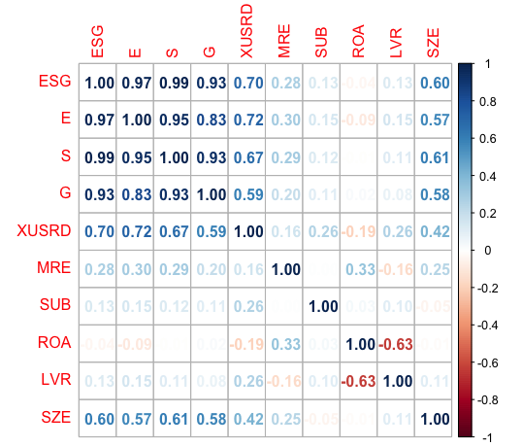

**Figure 2. Pearson Correlation Coefficient Matrix for (1), (2) Variables**

Visualization of the given matrix is given below.

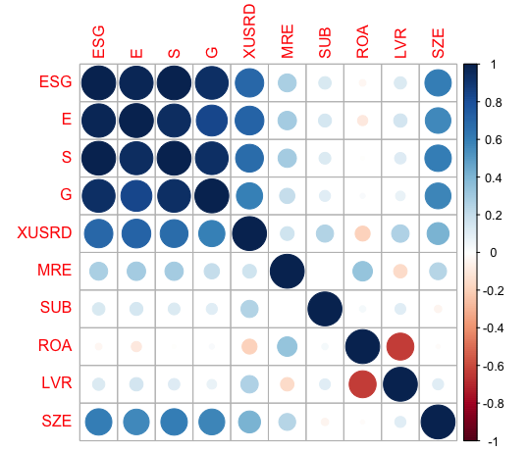

**Figure 3. Visualization of Pearson Correlation Coefficient Matrix for (1), (2) Variables**

As expected, each ESG pillar scores and ESG overall score are highly positively correlated. It should also be noted that, all ESG related variables are moderately high correlated with company size and XUSRD index involvement. Since XUSRD involvement depends on sustainability performance constraints, it can be said that it is also an expected outcome. Yet, it is important to emphasize that only 3 of the 22 XELKT companies satisfy requirements of XUSRD. Leverage ratio has negative correlation with companies’ profitability and war related market risks exposure.

### Test

Firstly, F Test is applied to decide whether pooled OLS model or fixed effects model is suitable for model (1). Since p value (0.0004) is much smaller than 0.05 level, we can reject the null hypothesis (pooled OLS is more suitable over fixed effects) and select fixed effects model. Secondly, Hausman Test is applied in order to choose more suitable model between fixed effects model and random effects model. Since p value (0.6046) is higher than 0.05 level, we can accept the null hypothesis which says random effects is more suitable over fixed effects.

In order to check the existence of serial correlation and heteroscedasticity, Breusch-Godfrey/Wooldridge and Breusch-Pagan Tests applied for random effects model. For the Breusch-Godfrey/Wooldridge test since p value (0.707) is above 0.05, it can be said that there is no serial correlation. For the Breusch-Pagan Test as p value (0.247) is higher than 0.05 level, it can be said that data has no heteroscedasticity.

Summary of the tests for model (1) and (2) are given below.

**Table 7. Summary of Tests for (1),(2)**

|  |  |  |
| --- | --- | --- |
| **Tests** | **(1) p value** | **(2) p value** |
| **F Test** | 0.0004 | 0.0016 |
| **Hausman Test** | 0.6046 | 0.6347 |
| **Breusch-Godfrey/Wooldridge Test** | 0.707 | 0.6736 |
| **Breusch-Pagan Test** | 0.247 | 0.664 |
| Both for (1) and (2) random effects are suitable. There is no serial correlation or heteroscedasticity. | | |

### Regression

Regression results for Model (1) and (2) are given below.

**Table 8. Random Effects Regression Results for (1), (2)**

| **All XELKT Companies** | | |
| --- | --- | --- |
|  | Dependent variable: | |
|  |  | |
|  | ROA | |
|  | (1) | (2) |
|  | | |
| ESG | 0.0002 |  |
|  | (0.001) |  |
|  |  |  |
| E |  | -0.001 |
|  |  | (0.001) |
|  |  |  |
| S |  | 0.001 |
|  |  | (0.002) |
|  |  |  |
| G |  | 0.001 |
|  |  | (0.001) |
|  |  |  |
| XUSRD | -0.053 | -0.047 |
|  | (0.042) | (0.042) |
|  |  |  |
| MRE | 0.064*** | 0.065*** |
|  | (0.018) | (0.019) |
|  |  |  |
| SUB | 0.009 | 0.010 |
|  | (0.011) | (0.011) |
|  |  |  |
| LVR | -0.279*** | -0.281*** |
|  | (0.060) | (0.058) |
|  |  |  |
| SZE | -0.005 | -0.005 |
|  | (0.008) | (0.008) |
|  |  |  |
| Constant | 0.228 | 0.241 |
|  | (0.180) | (0.175) |
|  |  |  |
|  | | |
| Observations | 80 | 80 |
| R2 | 0.406 | 0.433 |
| Adjusted R2 | 0.358 | 0.369 |
| F Statistic | 49.998*** | 54.113*** |
|  | | |
| Note: | *p<0.1; **p<0.05; ***p<0.01 | |

Since both models’ F statistics are significant, it can be said that both models are significant and descriptive. The war and leverage have significant in every p level. The Russia-Ukraine War has positive effect on Turkish energy companies’ profitability. On contrary, leverage affects companies’ profitability negatively. Though ESG or each pillar do not have significant impacts on profitability, while E pillar has negative relation S pillar has positive relation with ROA. The limited presence of ESG scores in the 80 observations could have impacted the outcome of the conclusion made from these models.

## “Responsible” Companies

Models (3) and (4) were used for "Responsible" companies. "Responsible" companies refer to the companies (AKENR.E, AKSEN.E, BIOEN.E, ENJSA.E, ESEN.E, GWIND.E, MAGEN.E, NATEN.E, ZOREN.E) in the XELKT index with sustainability scores that were different from 0 at any time between 2019 and 2022. In order to reduce complexity, all categorical variables (MRE, SUB and XUSRD) are omitted in these models.

### Correlation

Pearson correlation coefficient matrix for model (3) and (4) variables is given below as an heatmap.

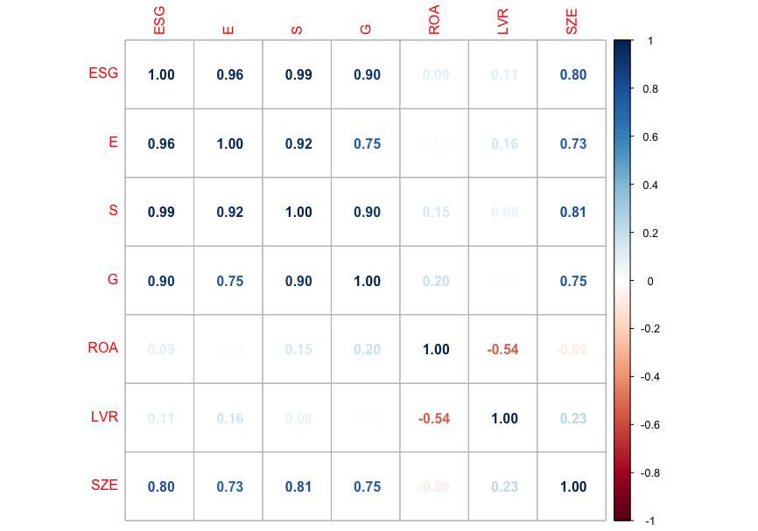

**Figure 4**. **Pearson Correlation Coefficient Matrix for (3), (4) Variables**

Visualization of the given matrix is given below.

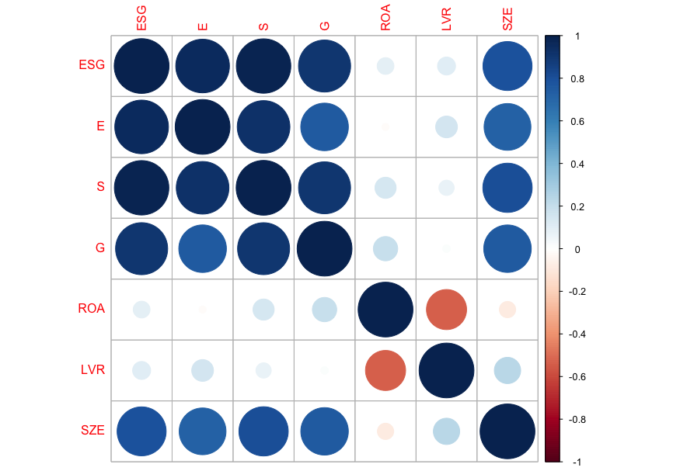

**Figure 5. Visualization of Pearson Correlation Coefficient Matrix for (3), (4) Variables**

As expected, each ESG pillar scores and ESG overall score are highly positive correlated. It should also be noted that, all ESG related variables are highly correlated with company size. Control variables, leverage ratio and company size, have positive correlation. Leverage ratio has negative correlation with companies’ profitability.

### Test

Summary of the tests for model (3) and (4) are given below.

**Table 9. Summary of Tests for (3),(4)**

|  |  |  |
| --- | --- | --- |
| **Tests** | **(3) p value** | **(4) p value** |
| **F Test** | 0.0001 | 0.0011 |
| **Hausman Test** | 0.8451 | 0.9953 |
| **Breusch-Godfrey/Wooldridge Test** | 0.4058 | 0.2421 |
| **Breusch-Pagan Test** | 0.1381 | 0.3735 |
| Both for (3) and (4) random effects are suitable. There is no serial correlation or heteroscedasticity. | | |

### Regression

Regression results for Model (3) and (4) are given below.

**Table 9. Random Effects Regression Results for (3), (4)**

| **“Responsible” Companies** | | |
| --- | --- | --- |
|  | Dependent variable: | |
|  |  | |
|  | ROA | |
|  | (3) | (4) |
|  | | |
| ESG | 0.001* |  |
|  | (0.001) |  |
|  |  |  |
| E |  | -0.002* |
|  |  | (0.001) |
|  |  |  |
| S |  | 0.003** |
|  |  | (0.001) |
|  |  |  |
| G |  | 0.0001 |
|  |  | (0.001) |
|  |  |  |
| LVR | -0.209* | -0.216* |
|  | (0.117) | (0.117) |
|  |  |  |
| SZE | -0.012 | -0.017 |
|  | (0.013) | (0.013) |
|  |  |  |
| Constant | 0.346 | 0.462 |
|  | (0.295) | (0.294) |
|  |  |  |
|  | | |
| Observations | 36 | 36 |
| R2 | 0.187 | 0.297 |
| Adjusted R2 | 0.111 | 0.180 |
| F Statistic | 7.365* | 12.703** |
|  | | |
| Note: | *p<0.1; **p<0.05; ***p<0.01 | |

It can be concluded that both models are valid and informative as their F statistics are significant. Results shows that, ESG, E pillar and S pillar have significant effects on ROA for models (3) and (4). Leverage ratio has also significant impact. While overall ESG and S pillar has positive impact on “responsible” companies’ profitability, E pillar has negative relation. Leverage ratio has negative impact as well. Thus, it can be inferred that sustainability plays a significant role in the financial performance of companies that incorporate sustainability reporting in their operations. Although the model is explanatory, the R-squared value reveals that the model's predictiveness is not very high.

# Conclusion

Within the scope of the study, the financial and sustainability performance of 22 companies listed in the BIST XELKT index was examined for the period between 2019-2022. Due to data availability, the study was carried out with 20 companies.

The study used panel data of XELKT companies to investigate the effects of ESG performance, subsectors, sustainability index inclusion, and market risk exposure on financial performance. Control variables such as leverage ratio and size of the companies were taken into account. The results of the first scenario showed that profitability was significantly affected by the Russia-Ukraine War and the company's leverage ratio, but ESG performance had no significant effect on the financial performance. In the second scenario, the scope of the dataset was narrowed to only "responsible" companies and the evaluation focused on the effects of ESG performance on financial profitability. The results showed that ESG performance had a significant positive effect on financial profitability, with the overall ESG and S pillar having a positive impact, but the E pillar having a negative relation.

Especially in the first scenario, it is very likely that the relationship between sustainability and financial performance, as interpreted in the model results, has been affected by the fact that only a small fraction of the 80 observations had an ESG score. The addition of the risk exposure as a dummy variable is also one of the factors that affect the result. In 2022, other developments (investments, technological developments, etc.) except war that may affect the financial performance of XELKT companies also affect the result. In the second scenario, when the sample size is reduced, it has been observed that for the companies already implementing sustainability practices, their sustainability performance has significant effects on their financial performance. When considering the possibility that sustainability practices will be mandatory in the future with upcoming regulations, it can be inferred that companies that already have sustainability practices in place will be prepared for potential financial liabilities. The possibility of a deepening of market risks with potential recession in the future also supports this conclusion. However, conclusions should be viewed with skepticism when drawing from a study based on a sample of only 20 companies.

In order to increase resolution of the model, quarterly data can be used instead of yearly data but due to data access limitation and project duration constraints this is unfortunately not the case. ESG data can also be evaluated on a quarterly basis if the release dates of the sustainability reports can be accessed. Again, when the possibility of mandatory sustainability reports is taken into account, the gap can be eliminated by monitoring the dates of companies' “KAP” announcements.

For further improvements, sub-sectors can be grouped and evaluated within themselves rather than being treated as dummy within the same panel. Although each sub-sector is exposed to the risks mentioned throughout the study, the possible impacts of the risks exposed are different. In addition, testing the model with different financial performance indicators found in previous studies can increase its robustness. However, this will bring more data points to check. Additionally, examining the ESG pillars in separate models can decrease the impact of correlation on the results. Finally, automating the data collection process can eliminate possible human errors that may affect the results.

**References**

[1] UN Climate Change Conference UK2021. (n.d.). COP26 Explained. Retrieved October 26, 2022, from https://ukcop26.wpenginepowered.com/wp-content/uploads/2021/07/COP26-Explained.pdf

[2] SHURA. (2022). *Türkiye Enerji Dönüşümü Görünümü 2021*. Retrieved October 26, 2022, from https://shura.org.tr/wp-content/uploads/2022/07/Outlook-rapor-3.pdf

[3] *Environmental, social and governance (ESG) scores from Refinitiv*. Retrieved October 12, 2022, from https://www.refinitiv.com/content/dam/marketing/en_us/documents/methodology/refinitiv-esg-scores-methodology.pdf

[4] Boffo, R., & Patalano, R. (2020). ESG investing: Practices, progress and challenges. Éditions OCDE, *Paris*.

[5] FSB. (2017). *Recommendations of the Task Force on Climate-related Financial Disclosures*. https://assets.bbhub.io/company/sites/60/2021/10/FINAL-2017-TCFD-Report.pdf

[6] *Sürdürülebilirlik Endeksi*. Borsa İstanbul A.Ş. Retrieved October 26, 2022, from https://borsaistanbul.com/tr/sayfa/165/bist-surdurulebilirlik-endeksi

[7] Zhu, B., Tang, J., Wang, P., & Zhang, L. (2022). Exploring the drivers of carbon market risk: A meta regression analysis. *Journal of Cleaner Production*, *352*, 131538.

[8] Berg, F., Koelbel, J. F., & Rigobon, R. (2019). Aggregate confusion: The divergence of ESG ratings. *Forthcoming Review of Finance*.

[9] Berg, F., Fabisik, K., & Sautner, Z. (2020). Is history repeating itself? the (un) predictable past of esg ratings. The (Un) Predictable Past of ESG Ratings (August 24, 2021). European Corporate Governance Institute–Finance Working Paper, 708.

[10] Sahin, Ö., Bax, K., Czado, C., & Paterlini, S. (2022). Environmental, Social, Governance scores and the Missing pillar—Why does missing information matter?. *Corporate Social Responsibility and Environmental Management*, *29*(5), 1782-1798.

[11] Ademi, B., & Klungseth, N. J. (2022). Does it pay to deliver superior ESG performance? Evidence from US S&P 500 companies. *Journal of Global Responsibility*, (ahead-of-print).

[12] Cornell, B., & Damodaran, A. (2020). Valuing ESG: Doing good or sounding good?. *NYU Stern School of Business*.

[13] Liu, P., Zhu, B., Yang, M., & Chu, X. (2022). ESG and financial performance: A qualitative comparative analysis in China's new energy companies. *Journal of Cleaner Production*, 134721.

[14] Shanaev, S., & Ghimire, B. (2022). When ESG meets AAA: The effect of ESG rating changes on stock returns. *Finance Research Letters*, *46*, 102302.

[15] Bruna, M. G., Loprevite, S., Raucci, D., Ricca, B., & Rupo, D. (2022). Investigating the marginal impact of ESG results on corporate financial performance. *Finance Research Letters*, *47*, 102828.

[16] Broadstock, D. C., Chan, K., Cheng, L. T., & Wang, X. (2021). The role of ESG performance during times of financial crisis: Evidence from COVID-19 in China. *Finance research letters*, *38*, 101716.

[17] Gao, J., Chu, D., Zheng, J., & Ye, T. (2022). Environmental, social and governance performance: Can it be a stock price stabilizer?. *Journal of Cleaner Production*, 134705.

[18] Albuquerque, R., Koskinen, Y., Yang, S., & Zhang, C. (2020). Resiliency of environmental and social stocks: An analysis of the exogenous COVID-19 market crash. *The Review of Corporate Finance Studies*, *9*(3), 593-621.

[19] Yoo, S., Keeley, A. R., & Managi, S. (2021). Does sustainability activities performance matter during financial crises? Investigating the case of COVID-19. *Energy Policy*, *155*, 112330.

[20] Demers, E., Hendrikse, J., Joos, P., & Lev, B. (2021). ESG did not immunize stocks during the COVID‐19 crisis, but investments in intangible assets did. *Journal of Business Finance & Accounting*, *48*(3-4), 433-462.

[21] Gillan, S. L., Koch, A., & Starks, L. T. (2021). Firms and social responsibility: A review of ESG and CSR research in corporate finance. *Journal of Corporate Finance*, *66*, 101889.

[22] Jahmane, A., & Gaies, B. (2020). Corporate social responsibility, financial instability and corporate financial performance: Linear, non-linear and spillover effects–The case of the CAC 40 companies. *Finance Research Letters*, *34*, 101483.

[23] Vuong, N. B. (2022). Investor sentiment, corporate social responsibility, and financial performance: Evidence from Japanese companies. *Borsa Istanbul Review*, *22*(5), 911-924.

[24] Aydoğmuş M., Gülay G. & Ergun K. (2022) Impact Of Esg Performance On Firm Value And Profitability , *Borsa istanbul Review* https://doi.org/10.1016/j.bir.2022.11.006.

[25] Ruan, L., & Liu, H. (2021). Environmental, social, governance activities and firm performance: Evidence from China. *Sustainability*, *13*(2), 767.